**P.2 LUGANDA LESSON NOTES FOR TERM I 2020**

**Kyosimba onaanya – kyolyako ettooke**

|  |  |  |  |  |
| --- | --- | --- | --- | --- |
| **Olunaku** | **Obudde** | **Ekibiina** | **Essomo** | **Omuwendo gwa baana** |
|  |  |  |  |  |

**Omutwe : Ennyingo**

**Ekiwayi : Ennyingo eziwangaala**

**Ebigendererwa: Okusoma ennyingo mubtuufu bwazo**

* **Okuwandiika ennyingo**

**Ensomesa : Kunyonyola**

* **Okukubaganya ebirowoozo**

**Walifu**

**Okusoma walifu**

a e i o u

w y c h Ƞ

b p v f m

d t l r n

z s j g k ny

**Okwawula ennukuta emperezi n’ensirifu**

**Okukola ennyingo n’okugatta ennyingo**

ba - to = bato la – ba = laba ga – ba = gaba

ma – ta = mata p + e = pe g +o = go

f + u = fu

**Ekinyusi : Enyingo eziwangaala**

Zikolebwa nga ekigambo birina ennukuta emperezi ezisomebwa awamu/ennukuta emperezi nga zidiringannidwa mu kigambo.

**Okugeza**

ab**aa**na t**aa**ta mul**ee**te m**aa**ma muk**ii**bi

**Gata ennyukuta okole ennyingo eziwangaala**

b + aa = baa m + aa = maa

d +aa = daa t+aa = taa

f + ee = fee m + ee = mee

k + aa = kaa l + ee = lee

k + ii = kii p + aa = paa

**Ebigamba**

baaba daaga kaana

baana feeza mukiibi

maama taata leeta

baaga taata leega

maala saaba paala

maansa kaaba paaka

**Omulimu**

Wandiika ebigambo bitaano ebiwangaala.

**Bbugubugu simuliro**

|  |  |  |  |  |
| --- | --- | --- | --- | --- |
| **Olunaku** | **Obudde** | **Ekibiina** | **Essomo** | **Omuwendo gwa baana** |
|  |  |  |  |  |

**Omutwe : Ennyingo**

**Ekiwayi : Ennyingo eziwangaala**

**Ebigendererwa: Okusoma emboozi z’ebigambo ebiwangaala**

* **Okukuba ebifaananyi okuva mu mboozi.**

**Ensomesa : Kunnyonyola**

* **Kukubaganya ebirowoozo**

**Ekinyusi : Emboozi z’ebigambo ebiwangaala**

**Okugeza**

* Maama anaaba
* Baaba akaaba
* Kafeero asaala
* Baaba atema omuti
* Mukiibi anaaza akaana

**Omulimu**

Soma okube ebifananyi.

1. Omukeeka guli ku mmeeza.
2. Omwaana akaaba.
3. Taata alina akataasa.
4. Mukiibi atudde kuntebe.
5. Baaba anaaba

**Konoweeka – Tokalinda kusaaba ttaka**

|  |  |  |  |  |
| --- | --- | --- | --- | --- |
| **Olunaku** | **Obudde** | **Ekibiina** | **Essomo** | **Omuwendo gwa baana** |
|  |  |  |  |  |

**Omutwe : Ennyingo**

**Ekiwayi : Ennyingo eziggumira**

**Ebigendererwa: Okugatta ennyingo ensirifu n’enjogeza**

* **Okusoma ebigambo n’emboozi**
* **Okukuba ebifaananyi**

**Ensomesa : Okunnyonyola**

* **Okukubaganya ebirowoozo**

**Ekinyusi : Gatta ensirifu bbiri n’enjoogeza emu okole ennyingo eziggumira.**

Ennyingo ezigumiira zifunibwa nga ekigambo kigatta ennukuta ensirifu ezomudiriȠanwa

**Okugeza**

jj + a = jja mm + e = mme

bb + a = baa pp + a = ppa

ff + u = ffu pp + I = ppi

gg + a = gga ss + a = ssa

ff + e = ffe tt + e = tte. nebirala

**Ebigambo**

jjajja ccupa jjamu jjuza

bbali ddiba ddalu ddamu

bbata ggala ddiza ssimu

ffumu ggobe kkovu ttaka

ffene jjayo kkobe ppipa

**Emboozi**

Jjajja alidde eggolu

Ffene agudde

Jjemba muddize eddiba

Nakigudde atudde kuntebe

**Omulimu**

1. Soma okube bino

ffene ssimu ekkovu

eppipa eccupa ettaka

1. Essimu eri ku mmeeza.
2. Ffene ali mu kibbo.

**Birungi sibirungi ng’omwana afaananye muliranwa**

|  |  |  |  |  |
| --- | --- | --- | --- | --- |
| **Olunaku** | **Obudde** | **Ekibiina** | **Essomo** | **Omuwendo gwa baana** |
|  |  |  |  |  |

**Omutwe : Ennyingo**

**Ekiwayi : Ennyingo ez’ennyukuta essatu**

**Ebigendererwa: Okusoma ennyingo**

* + **Okujjuzaamu ennyingo ezibulamu**

**Ensomesa : Okunnyonyola**

* + **Okukubaganya ebirowoozo.**

**Ekinyusi : Soma en nyingo**

mba mbe mbi mbo mbu

nfa nfe nfi nfo nfu

nza nze nzi nzo nzu

nka nke nki nko nku

nda nde ndi ndo ndu

mpa mpe mpi mpo mpu

**Omulimu**

Jjuzaamu ennyingo ezibulamu

1. nsa ________ __________ nso nsu
2. nta ________ nti ___________ _________
3. nfa ________ _________ ___________ fu
4. _______ nje nji ___________ _________

**Mwana mujimu ava ku ngozi**

|  |  |  |  |  |
| --- | --- | --- | --- | --- |
| **Olunaku** | **Obudde** | **Ekibiina** | **Essomo** | **Omuwendo gwa baana** |
|  |  |  |  |  |

**Omutwe : Ennyingo**

**Ekiwayi : Ennyingo ez’ennyukuta essatu**

**Ebigendererwa: Okusoma ebigambo eby’ennyingo ez’enyukuta essatu**

* + **Okukozesa ebigambo mumboozi**

**Ensomesa : OKUNNYONYOLA**

**- Okukubaganya ebirowoozo**

**Ekinyusi : Ebigambo eby’ennyingo ez’ennyukuta essatu.**

**Okugezza**  Okusoma ebigambo eby’enyukuta essatu

* **embaga - ensuwa**
* **ente - enva**
* **embuzi - envubu**
* **entamu - enzige**
* **enziro - ensansa**
* **entula**

**Emboozi**

1. Enva ziri muntamu
2. Abantu batudde kuntebe
3. Enzige ziri munsuwa
4. Envubu eri mu nsiko

**Omulimu**

1. **Kozesa ebigambo bino mu mboozi**

entamu

embaga

ensuwa

enva

envubu

**Gata enyingo okole ebigambo.**

wa

lo

2. nsu ku

ma

ga

1. mba lu

zzi

vu

Tuma bino amanya



omuti omukeeka emmotoka



amazzi eccupa ekikopo

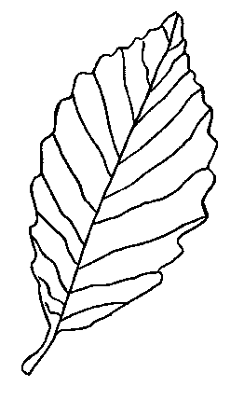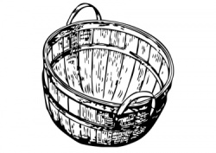

ekibbo ekikoola



**Omulimu**

**Juzaamu ennukuta ezibulamu**

 Omus __ta om ___lenzi m ___ ___ ma

 Ek __tabo ens ___wo

**Laga ekigambo ekituufu**

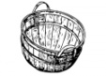Omupiira omupira dole ddole

Ekiseero ekisero kappa kkapa

Omuguwa omuguwa

**Mwana mubi – avumaganya nyina**

|  |  |  |  |  |
| --- | --- | --- | --- | --- |
| **Olunaku** | **Obudde** | **Ekibiina** | **Essomo** | **Omuwendo gwa baana** |
|  |  |  |  |  |

**Omutwe : Essomero lyaffe n’emiriraano gyalyo.**

**Ekiwayi : Ebintu ebiraga essomero lyaffe**

**Ebigendererwa: Okwogera ebintu ebiraga essomero lyaffe**

* + **Okukuba ebintu ebiraga essomero lyaffe**

**Ensomesa : Okubuuza no kuddamu**

**- Okunnyonyola**

**Ekinyusi : Ebintu ebiraga essomero lyaffe**

Essomero lyaffe liyitibwa Cornerstone Junior school . Lisangibwa ku kyalo Kitete mu Mukono.

**Ebiraga essomero lyaffe.**

1. Yunifoomu n’akabonero
2. Oluyimba lw’essomero
3. Ekipande ekiriko erinnya ly’essomero
4. Bbendera y’essomero
5. Essaala y’essomero
6. Motto y’essomero

**Omulimu**

**Soma okube ebifananyi**

1. Yunifoomu nakabonero ka Cornerstone
2. Bbendera y’essomero
3. Ekipande ekiriko erinnya ly’essomero.

**Basajja Mivule – gibwatula nejigumiza**

|  |  |  |  |  |
| --- | --- | --- | --- | --- |
| **Olunaku** | **Obudde** | **Ekibiina** | **Essomo** | **Omuwendo gwa baana** |
| 3/3/2011 | 9:00-10:00 | Kyakubiri | Luganda | 46 |

**Omutwe : Essomero lyaffe nemiriraano gyalyo.**

**Ekiwayi : Omuliraano byegufuna mussomero**

**Ebigendererwa: Okwogera abomuliraano kyebafuna mu ssomero lyaffe.**

**- Okutuuma emirimu amannya.**

**Ensomesa : Okunnyonyola**

**- Okukubaganya ebirowoozo**

**Ekinyusi : Essomero lyaffe liyamba abomuliraano okubawa emirimu.**

**Emirimu gyejino**

* Okusomesa
* Okuvuga emmotoka y’essomero
* Okuzimba
* Okusomesa
* Okubajja
* Okufumba
* Okulongoosa essomero nemirala

**Omulimi**

**Tuuma emirimu gino amannya.**

a b c







**Ssebugulu bwanyomo – bulekerera ekkubo n’ebuyita mu wanda**

|  |  |  |  |  |
| --- | --- | --- | --- | --- |
| **Olunaku** | **Obudde** | **Ekibiina** | **Essomo** | **Omuwendo gwa baana** |
|  |  |  |  |  |

**Omutwe : Emirimu gyabantu mukitundu kyaffe.**

**Ekiwayi : Okusoma emboozi**

**Ebigendererwa: Okusoma emboozi nokuddamu ebibuuzo**

**- Okukuba ebifananyi okulaga abantu nemirimu gyabwe.**

**Ensomesa : Okuwuliriza**

**- Okubuuza no kuddamu**

**Ekinyusi : Emirimu gyabantu**

**Okukola kintu kikulu nyo mubulamu bwaffe**

Abantu mukitundu kyaffe bakola emirimu egyenjawulo okufuna emmere oba okufuna ssente. Okugeza omulimi alima emmere gyetulya, omuserikale akuuma eddembe, omubazzi abajja ebibajje nga emmeeza, entebe nebirala. Omusomesa asomesa abayizi, omuzimbi azimba ebizimbe, kinyoozi asala enviiri ate omutuunzi atunga engoye. Nze njagala kuba musomesa kubanga omusomesa yasomesa bonna.

**Omulimu**

1. Wandiika emirimu emirala essatu. egikolebwa mu kitundu kyawamu

2. Bano bakolera wa emirimu gyabwe?

Omusomesa________________

Omulimi __________________

Kinyoozi __________________

3. Kuba ebifaananyi kumboozi zino

a) Omusomesa asomesa abayizi.

b) Kinyoozi asala enviiri.

c) Omubazzi abajja.

**koyikoyi, Nina mukazi wange atambula azina**

|  |  |  |  |  |
| --- | --- | --- | --- | --- |
| **Olunaku** | **Obudde** | **Ekibiina** | **Essomo** | **Omuwendo gwa baana** |
|  |  |  |  |  |

**Omutwe : Essomero lyaffe**

**Ekiwayi : Nakalazi webifo (prepositions)**

**Ebigendererwa: Okwogera ebifo ebintu webisangibwa**

**Okulaga ebintu ebimu webirekerwa ewaka ne kussomero**

**Ensomesa : Okukuba ebifaananyi**

**Okunnyonyola**

**Nakalazi w’ebifo bwebubonero obulaga ebintu w’ebiri**

**Ekinyusi : Ebiraga ekintu wekiri**

**Okugeza**

wansi waggulu kungulu kumpi

mumaaso mabega munda nebirala

**Ebyokulabirako**

 Omupiira guli wansi we ntebe



Ekikopo kiri ku mmeeza

**Omulimu**

 Kkapa eri__________w’omuti.



Ekkalaamu eri __________________kikebe.

 Omuwala ali ______________wa mmeeza.

nebirala

**End of theme test**

1. Wuliriza owandiike

_______________ _____________ ___________ ___________

_______________

1. Menya abantu basatu abasangibwa ku ssomero

_______________ _____________ ___________

1. Tuuma bino amannya

|  |  |  |  |
| --- | --- | --- | --- |
|  | a e i ou | C:\Users\lenovo\Desktop\drawings\all drawings others\table.PNG |  |
|  |  |  |  |

1. Kuba ebizimbe bino byetusanga ku ssomero

|  |  |  |
| --- | --- | --- |
|  |  |  |
| Ebibiina | Ekiyunga | kabuyonjo |

1. Saza ku bintu ebiraga essomero lyaffe
2. yunifoomu yessomero
3. ekikopo kyessomero
4. bbendera yessomero
5. ekipande ekiraga essomero

**Kyosimba onaanya - Kyolyako ettoke**

|  |  |  |  |  |
| --- | --- | --- | --- | --- |
| **Olunaku** | **Obudde** | **Ekibiina** | **Essomo** | **Omuwendo gwa baana** |
|  |  |  |  |  |

**Omutwe : Awaka waffe nekitundu mwetuli**

**Ekiwayi : Oluganda mu bantu bawaka**

**Ebigendererwa: Okwogera aboluganda abasangibwa awaka.**

**- Okwogera aboluganda ab’enju emu.**

**- Okusoma emboozi baddemu ebibuuzo**

**Ensomesa : Kubuuza nokuddamu**

**- Okukubaganya ebirowoozo**

**Ekinyusi :**

**Aboluganda betusanga ewaka**

Taata , maama, abaana (abawala na balenzi), jjajja omukazi, jjajja omusajja, kizibwe nabalala

Ab’oluganda munju emu

Maama, taata n’abaana

**Omulimu**

1. Menya abantu bataano ababeera ewaka
2. Kuba abantu bano abasangibwa ewaka

|  |  |  |
| --- | --- | --- |
|  |  |  |
| maama | taata | abaana |

1. Tuuma abantu bano betusanga ewaka

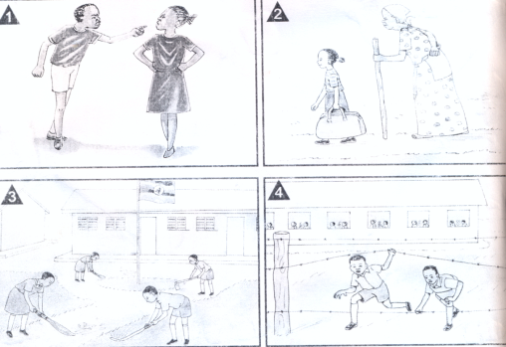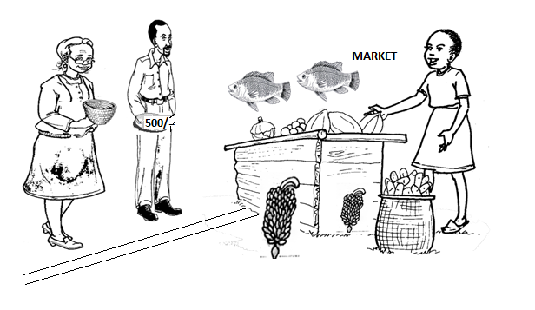

|  |  |  |  |  |
| --- | --- | --- | --- | --- |
| **Olunaku** | **Obudde** | **Ekibiina** | **Essomo** | **Omuwendo gwa baana** |
|  |  |  |  |  |

**Soma emboozi eno oddemu ebibuuzo.**

**Amaka ga mwami Kiggudde**

Mwami mutebi musajja wakitiibwa nyo. Alina omukyala omu n’abaana bataano. Ababiri bawala omuli Nakuya ne Namata, abalenzi kuliko Kato, Wasswa, n’e Kityo

Mwami Kigudde akola nnyo okulabirira amaka ge. Agula emmere eyokulya, engoye n’o kugunjula abaana. Mukyala we naye akola nnyo ng’alima, ayoza engoye, okufumba n’o kuyonja awaka. Abaana abawala bayambako maama wabwe okulongosa ennyumba, n’okufumba emmere, abalenzi nabo bakola ogw’okulima n’okusaawa awaka. Amaka gabwe masanyufu nnyo.

**Ebibuuzo**

1. Maka gaani agogerwako mu mboozi ?
2. Mulimu abaaana bameka?
3. Maama akola mulimu ki awaka?
4. Ani agula emmere awaka?
5. Abaana abalenzi bakola mirimi ki awaka?

**Kewerimidde - Kaakira mbegerako**

|  |  |  |  |  |
| --- | --- | --- | --- | --- |
| **Olunaku** | **Obudde** | **Ekibiina** | **Essomo** | **Omuwendo gwa baana** |
|  |  |  |  |  |

**Omutwe : Awaka waffe nekitundu mwetuli**

**Ekiwayi : Emirimu egikolebwa awaka**

**Ebigendererwa: Okumenya emirimu egikolebwa awaka**

* **Okusoma nokukuba ebifananyi**

**Ensomesa : Okunnyonyola**

* **Okukubaganya ebirowoozo**
* **Okubuuza nokuddamu**

**Ekinyusi :**

**Awaka tukola emirimu egyenjawulo era gyejino**

* Okulima
* Okukima amazzi
* Okusiimula ennyumba
* Okwoza engoye
* Okwera oluggya
* Okwoza ebintu nebirala

**Okuyunga emboozi ngabakozesa “ne”**

* Maama lima. Taata alima
* Maama ne taata balima
* Nakato afumba. Nalumu afumba.
* Ssenga ne baaba bafumba

**Omulimu**

**Soma okube ebifananyi**

1. Kato ayera oluggya
2. Nalule ayoza engoye.
3. Maama afumba emmere.
4. Abaana bava kukima mazzi.
5. Taata alima.

**End of theme test**

1. Wuliriza owandiike

__________ ___________ _________ _________ ________

1. Wandiika abantu bataano betusanga ewaka

__________ ___________ _________

1. Kuba abantu bano abasangibwa ewaka

|  |  |  |  |
| --- | --- | --- | --- |
|  |  |  |  |
| Jjajja omusajja | abaana | Jjajja mukazi | maama |

1. Wandiika emboozi okuva mu kabookisi

|  |  |  |
| --- | --- | --- |
| Nalule  Kato  Lumu  ssenga | afumba  ayera  ayoza  avuga | eggaali.  engoye.  emmere.  oluggya. |

1. ______________________________________________________
2. ______________________________________________________
3. ______________________________________________________
4. ______________________________________________________

**Nyama ntono okayana eri mu nkwawa**

|  |  |  |  |  |
| --- | --- | --- | --- | --- |
| **Olunaku** | **Obudde** | **Ekibiina** | **Essomo** | **Omuwendo gwa baana** |
|  |  |  |  |  |

**Omutwe : Awaka waffe nekitundu mwetuli**

**Ekiwayi : Ebisolo byetulunda awaka**

**Ebigendererwa: Okumenya amannya gebisolo byetulunda awaka.**

**- Okutuuma ebisolo amannya**

**Ensomesa : Okunnyonyola**

* **Okubuuza nokuddamu**

**Ekinyusi :**

**Awaka tulunda ebisolo ebyenjawulo nga bino:-**

Ente embwa

Embuzi kkapa

Embizzi

Endiga

n’ebirala

**Omulimu**

1. Kisolo ki ekikuuma ewaka?
2. Wa ebisolo bisatu ebirundibwa ewaka
3. Kuba ebisolo bino ebirundibwa ewaka

|  |  |  |
| --- | --- | --- |
|  |  |  |
| akamyu | embwa | embuzi |

**Tuuma ebisolo bino amannya**

|  |  |
| --- | --- |
|  |  |
|  |  |

.

**Kezaala kekomberera**

|  |  |  |  |  |
| --- | --- | --- | --- | --- |
| **Olunaku** | **Obudde** | **Ekibiina** | **Essomo** | **Omuwendo gwa baana** |
|  |  |  |  |  |

**Omutwe : Omubiri gwomuntu nebyobulamu**

**Ekiwayi : Ebitundu byomubiri**

**Ebigendererwa: Okusoma amannya gebitundu byomubiri.**

**- Okutuuma ebitundu byomubiri amannya.**

**Ensomesa : Okulaga**

**- Okubuuza nokuddamu**

**- Okukuba ebifaananyi**

**Ekinyusi : Ebitundu by’omubiri**

Omumwa engalo amaviivi

Ennyindo amabeere enviiri nebirala

amaaso omutwe

amatu ebigere

ensingo amagulu

**Omulimu**

**Ebitundu bino biwe amannya.**

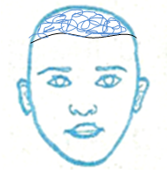 (ennyindo,okutu,eriiso,omumwa)

1. Kuba ebitundu by’omubiri bino

|  |  |  |  |  |
| --- | --- | --- | --- | --- |
|  |  |  |  |  |
| omutwe | amaaso | amatu | ebigere | amannyo |

**Totta kibe – nga tekinakenena ndusu**

|  |  |  |  |  |
| --- | --- | --- | --- | --- |
| **Olunaku** | **Obudde** | **Ekibiina** | **Essomo** | **Omuwendo gwa baana** |
|  |  |  |  |  |

**Omutwe : Omubiri gwomuntu nebyobulamu.**

**Ekiwayi : Emigaso gy’ebitundu byomubiiri**

**Ebigendererwa: Okumenya amannya gebitundu byomubiri**

* **Okuwas emigaso gyabyo**

**Ensomesa : Okukola ebikolwa**

* **Okubuuza nokuddamu**
* **Okunnyonyola**

**Ekinyusi : Ebitundu byomubiri**

**Ebitundu Emigaso**

amaaso galaba

omumwa gatuyamba okulaba

amagulu gatambula

amatu gawuliriza

ennyindo ewunyiriza

engalo zikwata

omutwe gwettikka

**Omulimu**

1. **Saza obukubo kukituufu**

amatu gatambula

ennyindo gwetikka

omutwe ewunyiriza

amaaso gawulira

amagulu galaba

1. Ebintu by’omubiri mubumi ne mubungi

eriiso __________________

ennyindo________________

1. Wa emigaso gyebitundu by’omubiri

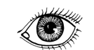

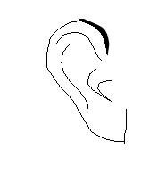



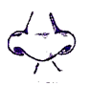

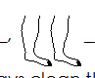

**Mwana mugimu ava ku ngozi**

|  |  |  |  |  |
| --- | --- | --- | --- | --- |
| **Olunaku** | **Obudde** | **Ekibiina** | **Essomo** | **Omuwendo gwa baana** |
|  |  |  |  |  |

**Omutwe : Omubiri gwomuntu nobuyonjo**

**Ekiwayi : Obuyonjo bwekifo mwetuli**

**Ebigendererwa: Okumenya ebifo ebyetaaga okukuuma nga biyonjo**

* **Okunnyonyola engeri gyetubikuuma nga biyonjo.**

**Ensomesa : Okukola ebikolwa**

* **Okubuuza nokuddamu**

**Ekinyusi :**

**Ebifo ebyetaaga okukuuma nga biyonjo**

* Ekinaabiro
* Kabuyonjo
* Kasasiro
* Ennyumba
* Oluggya
* Effumbiro n’ebirala

**Ebintu byetukozesa okweyonja**

Ebbaafu ziri ________________

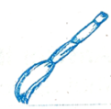

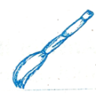 Enjeyo ziri _________________

D:\Drawings\Objects\Stool.tif Akatebe kali kamu ____________

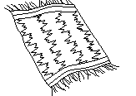**Okumenya n’okukuba ebintu byetukozesa okuyonja omubiri**

**C:\Users\lenovo\Desktop\drawings\all drawings others\sponge.PNG** ____________ _________________

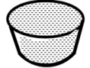

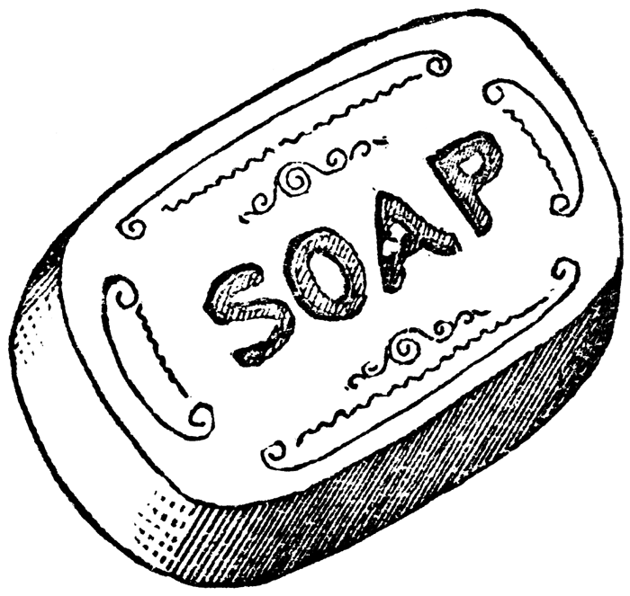 _______________

**Omulimu**

**Soma okube ekifananyi.**

1. Kato ayera oluggya
2. Musa asaawa oluggya
3. Naksi asiimula ennyumba
4. Nalule ayera effumbiro.

**End of theme test**

1. Wuliriza owandiike

__________ ___________ _________ _________ ________

1. Koloboza ku kituufu

amaaso gawulira

ennyindo gulya

ebigere galaba

omumwa ewunyiriza

amatu bitambula

1. Kuba ebitundu by’omubiri

|  |  |  |
| --- | --- | --- |
|  |  |  |
| amaaso | amatu | ebigere |

1. Tuuma bino byetukozesa okuyonja omubiri gwaffe



__________________________________



_____________________________________

C:\Users\lenovo\Desktop\drawings\all drawings others\sponge.PNG

**____________________________**

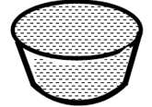 **______________________________**

**(amazzi, tawulo, ssabbuuni, ekyangwe)**

**Abataka abagalana – bebalima akambugu**

|  |  |  |  |  |
| --- | --- | --- | --- | --- |
| **Olunaku** | **Obudde** | **Ekibiina** | **Essomo** | **Omuwendo gwa baana** |
|  |  |  |  |  |

**Omutwe : Emmere ne migaso gyayo**

**Ekiwayi : Ebika by’emmere**

**Ebigendererwa: Okumenya ebika by’emmere**

* **Emmere ereeta amanyi**
* **Emmere ezimba omubiri**

**Ensomesa : Okubuuza nokuddamu**

* **Okunnyonyola**
* **Okukubaganya ebirowoozo**

**Ekinyusi : Emmere ereeta amaanyi**

muwogo omugaati

lumonde amatooke

bumonde akawunga n’ebirala

**Emmere ezimba omubiri**

amata ebyenyanja

enyama kawo

ebijanjaalo ebinyeebwa

amagi n’ebirala

**Omulimu**

1. Kuba ebifananyi by’emeere eno

muwogo enkoko

amagi lumonde

1. Saza ku meere ezimba omubiri

lumonde omugaati kawo

amagi amata omuceere

**kami katono – okanyomera mitala wamugga**

|  |  |  |  |  |
| --- | --- | --- | --- | --- |
| **Olunaku** | **Obudde** | **Ekibiina** | **Essomo** | **Omuwendo gwa baana** |
|  |  |  |  |  |

**Omutwe : Emmere nemigaso gyayo**

**Ekiwayi : Ebika by’emmere**

**Ebigendererwa: Okumenya emmere ekuuma omubiri nga mulamu**

* **Okutuuma emmere amannya**
* **Okumenya ebizibu ebiva mu kulya obubi.**

**Ensomesa : Okwawula**

* **Okubuuza no kuddamu**
* **Okunnyonyola**

**Ekinyusi : Emmere ekuuma emubiri nga mulamu.**

amapeera emiyembe ennanansi

ensusuuti emboga karoti

emicungwa nakati ebbugga n’ebirala

**Ebizibuy ebiva mu ndya embi**

* Okukonziba
* Obulema
* Okugwaamu amaanyi n’omusaayi
* Okufa
* Okuziba amaaso

**Omulimu**

**Biwe amannya.**



____________________ ____________________



____________________

|  |  |  |  |  |
| --- | --- | --- | --- | --- |
| **Olunaku** | **Obudde** | **Ekibiina** | **Essomo** | **Omuwendo gwa baana** |
|  |  |  |  |  |

**Omutwe : Obubonero**

**Ekiwayi : Okukozesa obubonero (, .)**

1. Tulina muwogo, lumonde ne kasooli.
2. Baganda bange be ba Kato, Wasswa ne Nakato
3. Kimera alina amaaso, amatu, ennyindo n’ebirala

**Obubonero**

**Okukozesa obubonero (. , ? !)**

1. Erinnya lyo gwani?
2. Maama abeera mu Kitete.
3. Maawo yani?
4. Omwana oyo nabba!
5. Jjajja wange naafa!

**Okusoma ebiseera**

**Ekiseera ekiriwo Ekiseera Ekyayita**

alima yalima

alya yalya

afudde yaffa

Wandiika emboozi zino mu kiseera ekyayita

Maama alima mu nnimiro.

Taata alya omuyemebe

**End of theme test**

1. Wuliriza owandiike

__________ ___________ _________ _________ ________

1. Menya emmere ezimba omubiri

__________ ___________ _________ _________

1. Saza ku mmere ekkuuma omubiri nga mulamu

emiyembe amagi

ennaanansi ebbugga

1. Kuba emmere eno etuwa amaanyi

|  |  |  |  |
| --- | --- | --- | --- |
|  |  |  |  |
| muwogo | ettooke | obumonde | Kasooli |

1. Koloboza emmere n’egyetugijja

omucceere mu nnyanja

muwogo mu dduka

engege mu nnimiro